Log Regression

**Descriptions:** Logistic regression is the nonparametric version of regression or discriminant analysis. Since log regression is nonparametric, you have more flexibility with variables because there are no normality assumptions. Log regression is used to predict group membership, so the outcome variable is categorical. The predictor variables can be a mix of categorical or continuous variables.

**Definitions:**

* IV(s) – these are your predictor variables. You are using them to predict group membership (akin to discriminant analysis). They can be any combination of types of variables: categorical, continuous, Likert…and they do not have to be normally distributed.
  + You will want to dummy code your categorical variables with more than two categories! Sometimes, SPSS will create the dummy variables for you.
* DV – this variable is your group classification or group membership.
* Equation:
  + Regular regression: Y-hat = a + bx1 + bx2 + bx3 …
  + Log regression: Y-hat = eu / 1 + eu
  + U = a + bx1 + bx2 + bx3
  + Therefore, when you get predicted group membership, you are getting the *log odds* of a person being in one group over other.
    - Think about this like sports betting…when you bet on something, there are odds if you are going to win. Log odds is the probability that you will be in one group over another.

**Types of Log Regression:**

Binary Logistic Regression – only two outcome categories.

Multinomial Logistic Regression – three or more outcome categories.

1. Direct Logistic Regression – same as simultaneous regression. All predictors are entered into the equation at the same time. Usually used when there is no theory about order of variables or no “control” variables.
2. Sequential/Hierarchical Logistic Regression – you enter variables in steps or groups based on some pre-determined order. You will look at the addition or change in models when you add the new sets.
3. Statistical (stepwise) Logistic Regression – usually used in psychology as a screening procedure for correlated IVs. Enters variables into the equation based on their ability to predict – criticized for its lack of theory-based decisions.
4. Probit – often considered the half-way point between log regression with purely categorical DVs and regular regression with purely continuous DVs. Probit has the assumption that the DV is normally distributed, but is not totally continuous (like a likert scale!).

**Power:**

* Most likely run as a regular regression. Log regression will have more power than regular regression when the assumptions are not met.
* You can use the estimates from G*Power and a regression model (depending on direct, hierarchical) and get a good number of subjects to run.

**Assumptions/Issues:**

* Categorical DVs – you have to have groups as your outcome variable. You can have as many as you want, but it does make interpretation more difficult the more groups you have.
* Ratio of Cases (small N) – you want to have non-small expected and observed frequencies in each outcome category. If you have a very small category, it will be hard to predict (and more probable to predict the big category). You can collapse categories that are small or collect more data.
  + Also you want to have more participants in your study than independent variables. You will get perfect predictors (bad) if you have a small number of people and lots of predictors.
* Multicollinearity – you still do not want to use two predictor variables that overlap in variance a great deal (but you can use hierarchical log regression if you have that problem and don’t want to combine the predictors).
* Outliers in the Solution – you can have outliers in the data, but people with high residual values (meaning you didn’t predict them well at all) should be examined to understand why they were in their group, but are unpredictable.
* Independence of errors – you can only be classified in **one** group. You cannot be part of two of the outcome groups. Therefore, no repeated measures variables.

**Theoretical Interpretations/Issues:**

1. Goodness of Fit Models:
   1. Y-intercept models only – usually Block 0 of your output. This model tests only the mean of all the predictors at 0 to see if that predicts groups.
   2. Incomplete models – Block 1-X on your output. These models will be some of your predictors (like in hierarchical regression). You want these models to be significantly better than the Y-intercept model.
   3. Complete/full models – all the predictors that you wanted to use to predict category membership. You want this model to be significantly greater than an incomplete model.
   4. Perfect model – theoretical model, in a perfect world, you could classify everyone correctly. You do not want a significant difference between this theoretical model and your complete model (because that means you are doing the best job at predicting that you can).
2. Deciles of Risk - Compares the number of people predicted to be in each group against the actual number of people in each group
   1. Hosmer-Lemeshow – you want this statistics to be non-significant, saying that you predict the actual people in each group correctly.
3. Individual Predictors in the equation
   1. Wald test – wald test is similar to testing if a b/beta is significantly different from zero, it’s a type of chi-square analysis.
   2. Omission – does the model get worse when I leave it out?
   3. You want these tests to be significant.
4. Effect Sizes
   1. *R2/eta* (only for binary log regression) – you have to correlate predicting category with real category.
   2. *p2*– mimics R2 with range of 0-1, ratio of likelihood ratios
      1. Smaller numbers than R2 usually, .2-.4 is a good range.
   3. Cox and Snell – R2 based on likelihoods and sample size
      1. BUT never can reach 1, even if you achieve perfect fit.
   4. Nagelkerke R2 – adjusts Cox and Snell so that the upper limit is 1 – most people report this type of effect size.
5. Interpretation of Log Odds (expB)
   1. Instead of thinking about B values as correlations or increase/decrease in variables, we are talking about the odds change when predictors increase.
   2. Odds ratios greater than 1 = increase of the odds of that outcome
   3. Odds ratios less than 1 = decrease in the odds of that outcome.
   4. The comparison group is the group coded as 0.
      1. So if your odds ratio is greater than 1, you have an increase in the odds of being in the 1 group.
      2. Less than 1 decrease in odds of the 1 group (or increase in the 0 group).
   5. Closer to 1 = close to 50/50 = low effect size.
   6. Smaller/bigger = bigger effect size
   7. Smaller odds ratios = are similar to negative beta values.
   8. The further away from 1 a predictor is – the better that predictor is, remembering that they cannot go below zero.
6. Coding (with multinomial log regression):
   1. You will have two log regressions.
      1. 0-1 equation.
      2. 0-2 equation.
      3. Etc.
   2. Hence why 0 needs to be your reference category you want to compare every other group to.
   3. If you want 0-1, 1-2, you have to recode or specify when you run the analysis.

Complete Example Binary

**Research Question:** Can we correctly predict working and nonworking individuals by attitudes and demographics?

Classification variable/DV:

* Work status (working or not).

IV(s):

* Children – yes or no
* Race – white or other
* CONTROL – Locus of Control
* ATTMAR – attitude toward marriage
* ATTROLE – attitude toward role of women
* SEL – socioeconomic status
* ATTHOUSE – Attitude toward housework
* Age
* Education level

Power

G*Power options include:

* F-test
* Linear multiple regression: fixed model R2 deviation from zero
  + (R2 increase would be for hierarchical regression)
* Effect size f2 – you would need to estimate based on research or you can hit determine
  + Rho = estimate based on r2
* Alpha = .05
* Beta = .80
* Number of predictors = number of IVs.

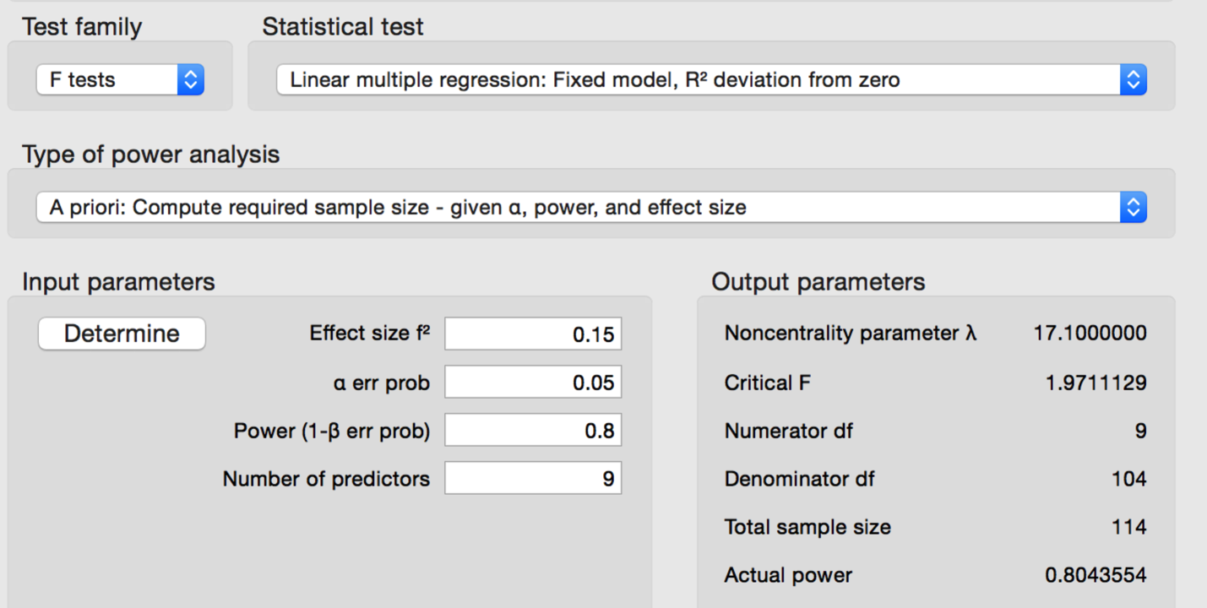

Assumptions:

* Multicollinearity
  + Analyze > Correlate > Bivariate.
  + Move over the predictor (IV) variables.
  + Check to see if they are above .9.

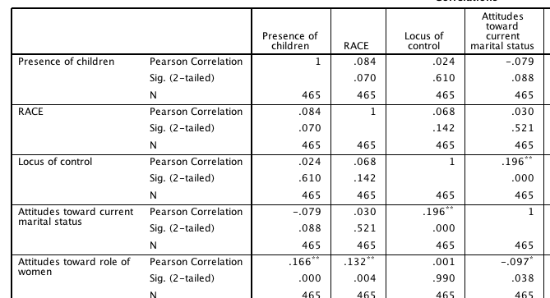

* Case size – see below, can be easily viewed when the analysis is run.

How to Run:

1. Analyze > Regression > Binary Logistic

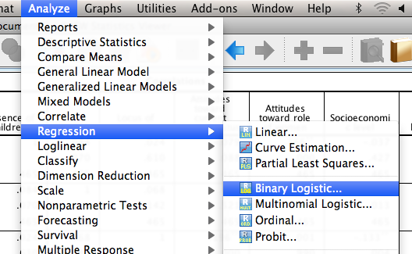

1. Put your classification variable in the dependent box. You will get a warning if you try to run this with more than two categories.
2. Put all your predictor IV variables in the covariates box.
   1. If you want interactions, click those two variables and then hit >a*b> button.

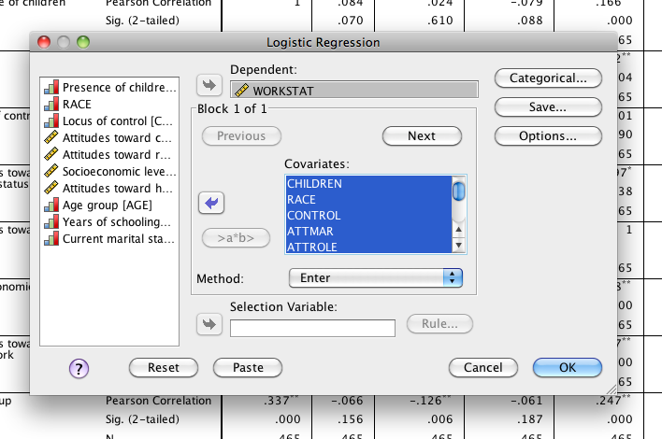

1. Hit the categorical option button.
   1. Move over the categorical predictors into the categorical covariates box.
   2. Most people compare with the first – meaning that log odds for over 1 = the second group, and log odds under 1 = the first group.

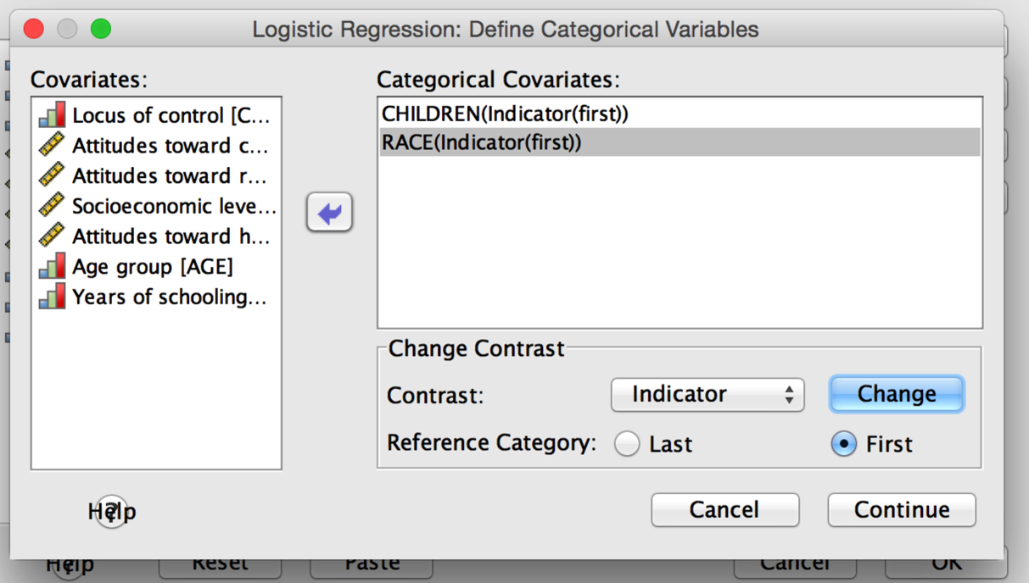

1. Hit options.
   1. Select classification plots.
   2. Select Hosmer-Lemeshow goodness of fit statistic.

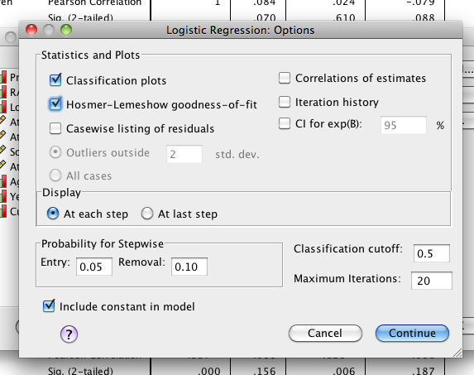

Reading the Output:

1. Dependent variable encoding:
   1. You will use this box to figure out who is group 0 and who is group 1. We are comparing working to not working.
      1. B values > 1 go into the not working group.
      2. B values < 1 go into the working group.

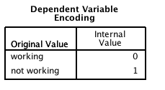

1. Categorical Variable Codings
   1. This box tells you what you signified as categorical predictors and how many there were of them. It also shows you the way it’s set up as 0 and 1, which you’ll use to interpret the expB values.

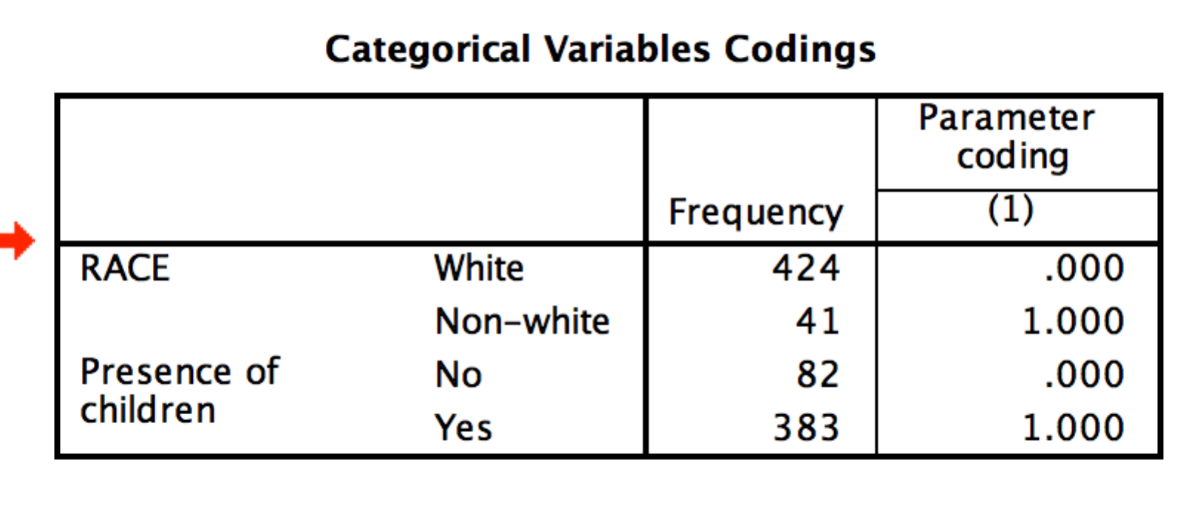

1. Block 0 – this is the y-intercept only model.
   1. The classification table tells you how you did at classifying people into groups.
   2. You can also see if you have very small number of cases in one of the groups here. We have ~200 in each group, so we are ok.
   3. Here it classified everyone into the working category. That’s bad.
2. The variables in the equation box for block 0.
   1. This box tells you the log odds for the constant…it’s negative so we are predicting everyone will go into group 0 or the working group.
   2. You want this model to be NON-SIGNIFICANT. Otherwise that means that your predictors are not useful.
   3. You can ignore the variables not in the equation box.

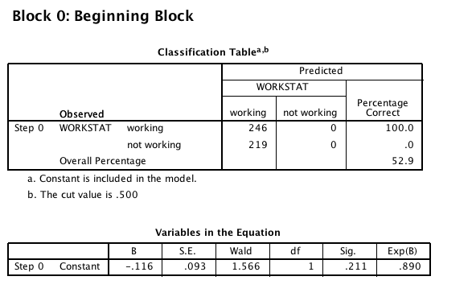

1. Block 1 – In a binary direct logistic regression, this box contain the complete model. You will have all your variables entered into this model.
   1. Omnibus Tests of Model Coefficients
      1. This information is whether or not ALL your predictors were significant at classifying your group membership. You want this model to be significant.
      2. Step, Block and Model will be different in a hierarchical regression.

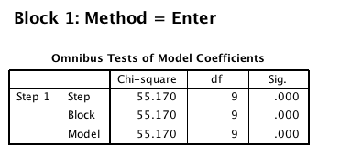

* 1. Model Summary – you can get effect size (most people report Nagelkerke R2) from the model summary box. It tells you ALL the predictors variance accounted for.
     1. Here, we did pretty good – about 15% of the variance.

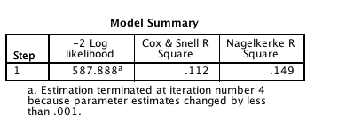

* 1. Hosmer and Lemeshow Test – you DO NOT want this information to be significant.
     1. The test breaks down your data into 10ths. From there, it uses a chi square test to determine if the observed values (the number of people in either group for real) are equal to the expect values (Y-hat given your equation).
     2. Since you are wanting to correctly classify people, you want observed to equal expected.

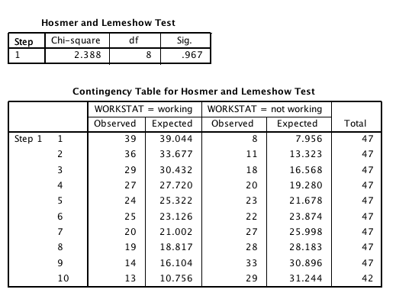

* 1. Classification Table – Similar to discriminant, you have the predicted categories given your equation. You want the match places (working/working) to be high. The percentage correct just tells you how good at each category and overall how well the model predicts. We’re at 64%, which is better than chance.

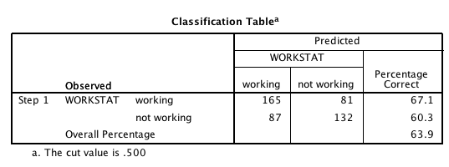

* 1. Variables in the equation – here is where you can look at the significance values and predicted log odds for each individual predictor.
     1. Just like we report beta in regular regression, most people report ExpB for log regression.

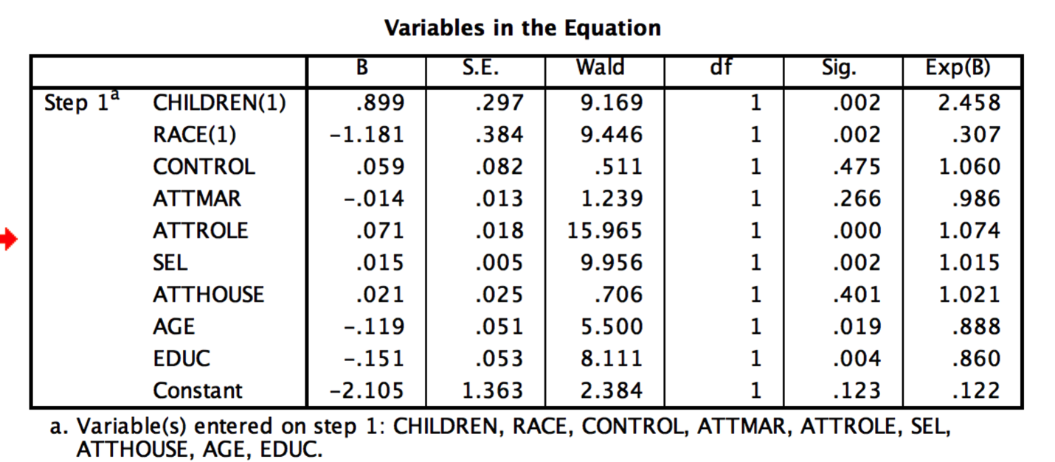

* 1. Interpretation: It usually helps if you make yourself a chart.
     1. First label the significant predictors.
     2. Then put < 1s into group 0.
     3. Put the > 1s into group 1.
     4. With the categorical predictors, the number indicates which coding goes into that group.
     5. With continuous predictors you always think about, as this goes up, the likelihood for group X increases.

|  |  |  |
| --- | --- | --- |
|  | Working | Not Working |
| Children |  | 2.458  1 = children  People with kids more likely to not be working. |
| Race | .307 expB  1 = other  Other people are working (not white). |  |
| Attitude Role of Women |  | 1.074  As att roles of women go up, you are more likely to not be working. |
| SES (Sel) |  | 1.015  As socioeconomic status goes up, you are more likely to not be working. |
| Age | .888  As age goes up, you are more likely to be working. |  |
| Education | .860  As education goes up, you are more likely to be working. |  |

1. Classification picture – with this chart you can see where everyone was classified. For the people you got incorrect, where they close to the cut off? Or are they extremely wrong?
   1. This picture will also show you outliers in the solution.

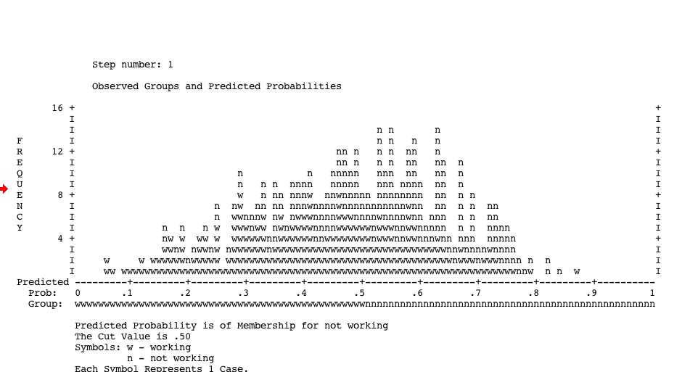

Write Up:

**Results**

A direct binary logistic regression analysis was conducted to evaluate membership prediction for working and not working individuals using the presence of children (yes or not), race (Caucasian or other), locus of control, attitudes of the role of women, marriage, housework, socioeconomic status, age and education. 465 participants were included in this analysis: 246 for the working category and 219 for the not working category. Multicollinearity between variables was not present in the dataset.

The constant only model was tested, but was not significant, Wald (1) = 1.57, *p*=.21. This model classified all cases as working, which correctly classified 52.9% of the data at chance. The full model included the variables listed above and was significant, *X2*(9) = 55.17, *p*<.001, Nagelkerke *R*2=.15. The Hosmer-Lemeshow test showed the model had good fit with a non-significant chi-square, *X2*(8) = 2.39, *p*=.97. Overall, 63.9% of the participants were correctly classified, with slightly better classification in the working group (67.1%) over the non-working group (60.3%).

Please see Table 1 for exponent B values and their significance levels. Locus of control, marriage status attitude, and housework attitude were all non-significant predictors of working status. In general, participants who did not have children, were older, and had more education were likely to be classified in the working category. Caucasian participants, with high attitudes about the role of women, and high socioeconomic status were more likely to be classified in the non-working category.

Table 1. *Exponent B and Significance Values for Predictors.*

|  |  |  |  |  |  |
| --- | --- | --- | --- | --- | --- |
|  | *B* | *S.E.* | *Wald* | *p* | *Exp(B)* |
| Children (yes) | 0.899 | 0.297 | 9.169 | 0.002 | 2.458 |
| Race (non-white) | -1.181 | 0.384 | 9.446 | 0.002 | 0.307 |
| Locus of Control | 0.059 | 0.082 | 0.511 | 0.475 | 1.060 |
| Marriage Attitude | -0.014 | 0.013 | 1.239 | 0.266 | 0.986 |
| Role of Women Attitude | 0.071 | 0.018 | 15.965 | 0.000 | 1.074 |
| Socioeconomic Status | 0.015 | 0.005 | 9.956 | 0.002 | 1.015 |
| Housework Attitude | 0.021 | 0.025 | 0.706 | 0.401 | 1.021 |
| Age | -0.119 | 0.051 | 5.500 | 0.019 | 0.888 |
| Education | -0.151 | 0.053 | 8.111 | 0.004 | 0.860 |
| Constant | -2.386 | 1.377 | 3.003 | 0.083 | 0.092 |
| *Note.* *df* = 1. |  |  |  |  |  |

Complete Example Hierarchical

**Research Question:** Can we correctly classify criminals who are going to commit a second crime?

Classification/DV:

* Arrest 2 – if they were arrested again or not.

Predictor/IV(s):

* Demographics:
  + Age
  + Martial – yes/no married
  + Social – socioeconomic status (low, medium, high)
  + Ed – level of education (no HS, HS, College, Past College)
  + Gender
* Other variables
  + Employ – if they are employed
  + Crime 1 – what their first crime was.
  + Violent 1 – if their first crime was violent
  + Rehab – if they attended rehab.

Power:

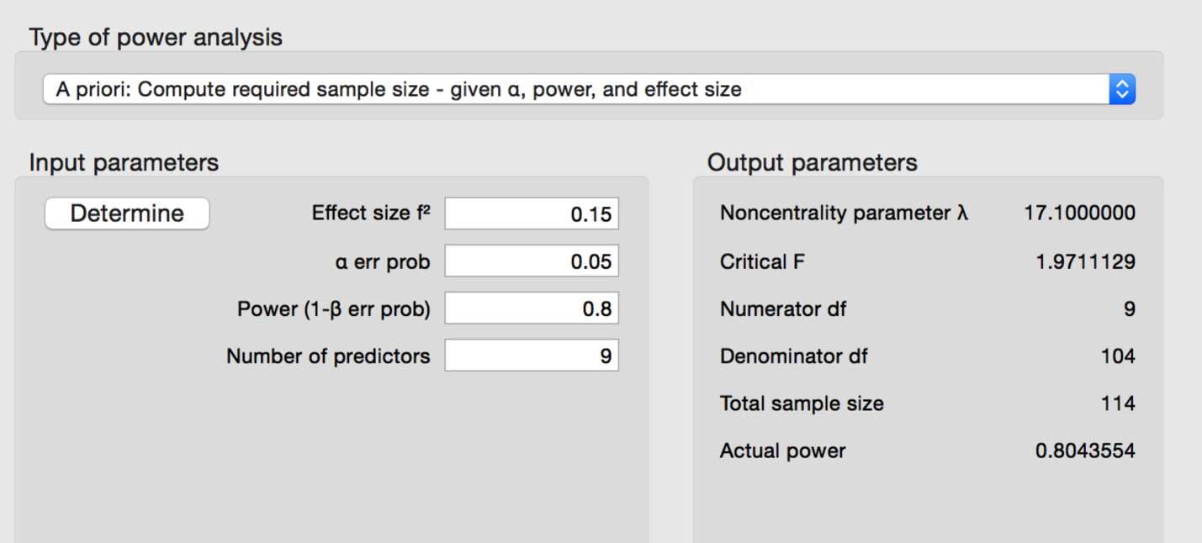

Assumptions:

* Multicollinearity – nope.

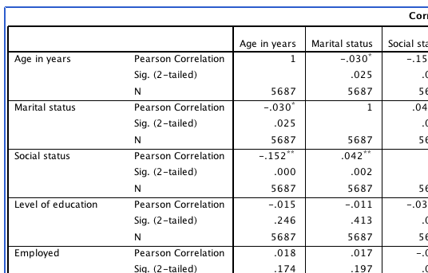

* Cases ratio: also not an issue.

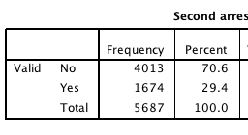

How to Run:

1. Analyze > Regression > Binary Logistic (because we have two outcomes, yes/no).
2. Put DV/classification variable in the dependent box.
3. Put your first step (demographic variables into the covariates box.

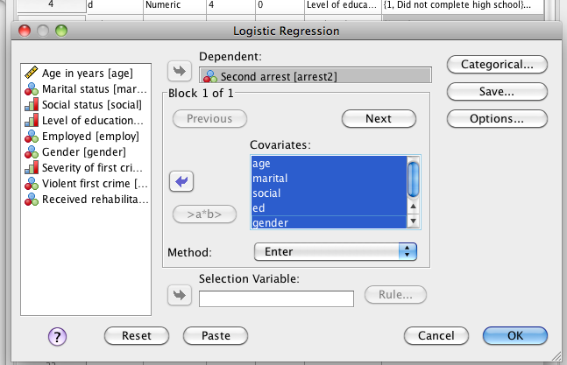

1. Hit next.
   1. Put the second set of variables about after crime committed into the covariates box (this is your second step).

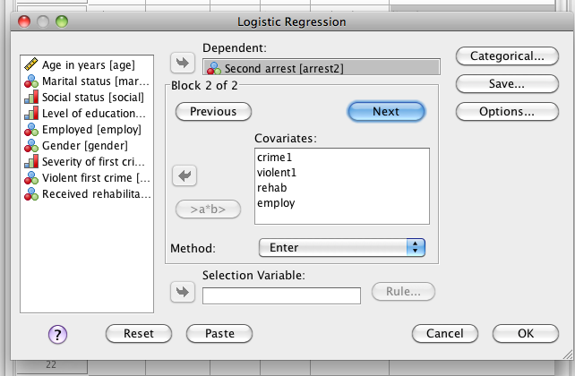

1. Hit categorical. Move over the categorical variables. Change to first reference.

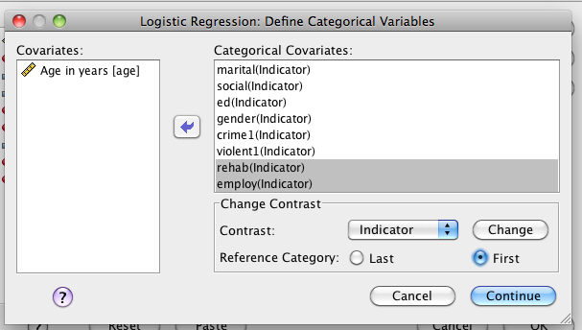

1. Hit options – ask for classification plots and Hosmer-Lemeshow.

Reading the Output:

1. Dependent variable encoding:
   1. Our group 0 = no, group 1 = yes.

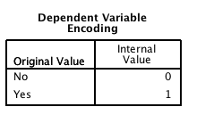

1. Categorical variable codings – this box will help you understand the coefficients box. For example, Class B misdemeanor = severity(1). Not copied completely because of size.

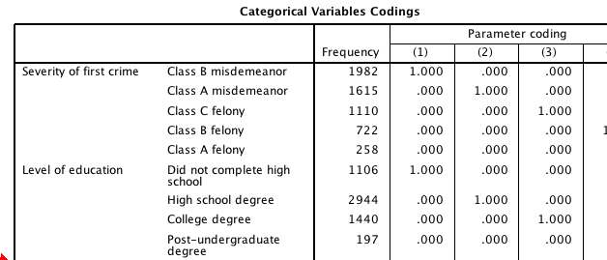

1. Block 0 is your constant only model. This model you do NOT want to be significant.
   1. Our classification table shows that everyone was lumped into the no category, which is about 70% of the dataset. That’s not very good prediction, but will be significant, because that’s greater than 50-50.

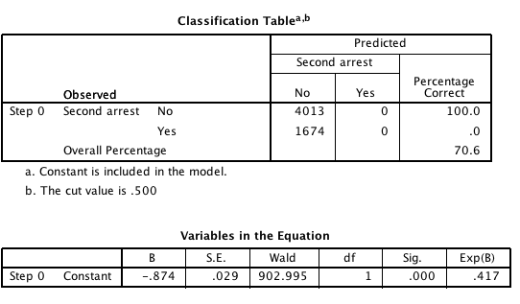

1. Block 1 = your incomplete model. This block is step 1 or only your demographic information.
   1. It appears that our demographics are a significant predictor of recidivism. As shown in the Test of model coefficients.

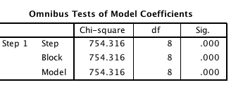

* 1. Also it’s about 18% of the variance.

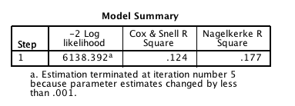

* 1. The Hosmer-Lemeshow statistic is significant (not what you want), indicating that while the predictions were significant, you didn’t do that great.

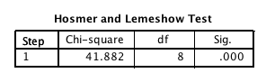

* 1. Our classification table shows that we got about 92.5 of the no people correct, but only 27.4 of the yes people correct. Overall, that’s 73.3, which isn’t much better than the constant only model.

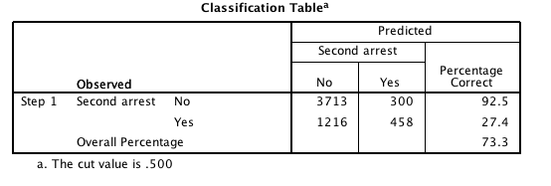

* 1. The variables box shows you how well the classification worked for each variable.
     1. If Block 2 is NOT significant, you will interpret these coefficients, because the addition of after crime information did not help you predict people.
     2. If Block 2 IS significant, you usually interpret the coefficients from the final model.

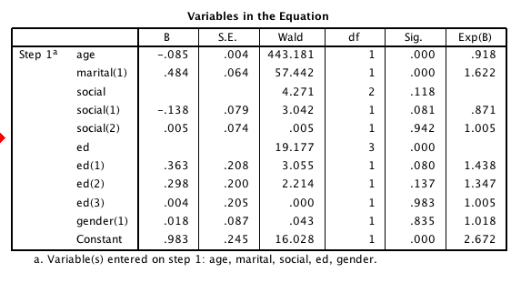

1. Block 2 – the complete model – you want this to be significant for sure!
   1. Now you’ll see that block and model are different numbers.
      1. Block is that individual block (like change in r square from regular regression).
      2. Model is the entire complete set of variables.
      3. You want block to be significant, indicating that the addition of those variables was useful.

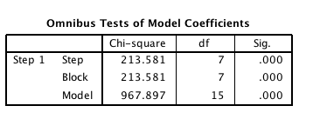

* 1. We are up to 22% of the variance.

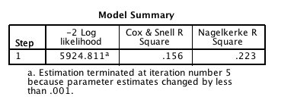

* 1. We are doing better on the Hosmer-Lemeshow, but still not the best prediction.

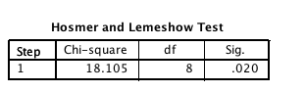

* 1. Our classification table shows us that the crime data helps us better classify the Yes second repeaters more. But with 74.6% overall.

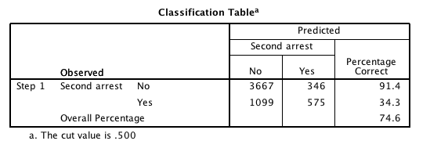

* 1. Variables in the equation – interpret this box since block 2 was significant. Again, it’s easier with a table.

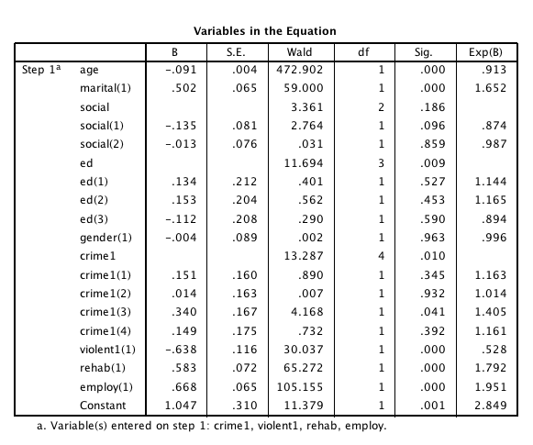

1. Interpretation of the coefficients.
   1. Sometimes what you find is that overall the education variable is significant (that’s the ed only line). But then none of the individual groups are significant. What that means is that your comparison of the group coded ALL as zeros and then the group coded 1 is not different. Sometimes people switch the coding around to figure out which groups are significant.

|  |  |  |
| --- | --- | --- |
|  | No | Yes |
| age | 0.913  as age goes up, you are less likely to commit a second crime |  |
| martial (1) |  | 1.65  1=unmarried  unmarried people are more likely to commit a second crime. |
| crime (3) |  | 1.41  3 = class C felony folks are more likely to commit another crime. |
| violent (1) | 0.53  1 = no, non-violent folks are likely to NOT commit another crime. |  |
| rehab (1) |  | 1.79  1 = no  no rehab people are likely to commit another crime |
| employ(1) |  | 1.95  1 = no  unemployed people are likely to commit another crime. |

Write Up:

**Results**

Sequential logistic regression was used to predict a criminal’s recidivism or whether or not they would commit a second crime. In total, 5687 participants were analyzed with 4013 that did not commit a second crime and 1674 that did commit a second crime. Predictor variables were checked for multicollinearity and were not highly correlated. Demographic information was entered into the first step of the analysis; age, martial status (yes or no), socioeconomic status (low, medium, high), gender, and education level (no high school, high school, college, post college). Crime information was entered into the second step of the logistic regression to examine it’s predictive value after controlling for demographics; employment status (yes or no), crime type (misdemeanor or felony type), violent crime (yes or no) and whether they attended rehabilitation or not.

The constant only model correctly predicted 70.6% of cases by classifying all participants in the no second crime category. This model was significant, Wald (1) = 903.00, *p*<.001, but was not very useful in predicting second crimes. The addition of demographics significantly increased our prediction ability, X2(8) = 754.32, *p*<.001, Nagelkerke *R*2=.18, however, the Hosmer-Lemeshow showed poor fit again for the committing a second crime category, X2(8) = 41.88, *p*<.001. This model correctly predicts 92.5% of no crime participants, 27.4% second crime participants, and 73.3% overall.

The final model included a significant addition to the variance, X2(7) = 213.58, *p*<.001, and was a significant prediction equation overall, X2(15) = 967.90, *p*<.001, Nagelkerke *R*2=.22. The Hosmer-Lemeshow test was still significant, but was closer to expected values, X2(8) = 18.11, *p*=.02. The final model correctly classified 74.6% of participants overall, 91.4% of participants who did not commit a second crime, and 34.3 percent of participants who did commit a second crime.

Table 1 contains the final model predictor information. Age and violence of the first crime were important predictors for the non-second crime participants. As participants aged, they were less likely to commit a second crime. Also, if the first crime was not violent, participants were less likely to commit a second crime. Education overall was a significant predictor of group membership, which appeared to show that less education led to a second crime. Unmarried participants, participants who did not attend rehabilitation, and unemployed participants were more likely to commit second crimes. Finally, participants whose first crime was a class C felony were more likely to commit a second crime.

Table 1. *Predictor Values for Final Model*

|  |  |  |  |  |  |  |
| --- | --- | --- | --- | --- | --- | --- |
|  | *B* | *S.E.* | *Wald* | *df* | *p* | *Exp(B)* |
| Age | -0.091 | 0.004 | 472.902 | 1.000 | 0.001 | 0.913 |
| Unmarried | 0.502 | 0.065 | 59.000 | 1.000 | 0.001 | 1.652 |
| Social Overall |  |  | 3.361 | 2.000 | 0.186 |  |
| Lower Class | -0.135 | 0.081 | 2.764 | 1.000 | 0.096 | 0.874 |
| Middle Class | -0.013 | 0.076 | 0.031 | 1.000 | 0.859 | 0.987 |
| Education Overall |  |  | 11.694 | 3.000 | 0.009 |  |
| No HS | 0.134 | 0.212 | 0.401 | 1.000 | 0.527 | 1.144 |
| HS | 0.153 | 0.204 | 0.562 | 1.000 | 0.453 | 1.165 |
| College | -0.112 | 0.208 | 0.290 | 1.000 | 0.590 | 0.894 |
| Male | -0.004 | 0.089 | 0.002 | 1.000 | 0.963 | 0.996 |
| Crime Overall |  |  | 13.287 | 4.000 | 0.010 |  |
| Class B Mis | 0.151 | 0.160 | 0.890 | 1.000 | 0.345 | 1.163 |
| Class A Mis | 0.014 | 0.163 | 0.007 | 1.000 | 0.932 | 1.014 |
| Class C Felony | 0.340 | 0.167 | 4.168 | 1.000 | 0.041 | 1.405 |
| Class B Felony | 0.149 | 0.175 | 0.732 | 1.000 | 0.392 | 1.161 |
| Not Violent Crime | -0.638 | 0.116 | 30.037 | 1.000 | 0.001 | 0.528 |
| No Rehab | 0.583 | 0.072 | 65.272 | 1.000 | 0.001 | 1.792 |
| Not Employed | 0.668 | 0.065 | 105.155 | 1.000 | 0.001 | 1.951 |
| Constant | 1.047 | 0.310 | 11.379 | 1.000 | 0.001 | 2.849 |

Complete Example Multinomial

**Research Question:** Can we correctly predict anorexic only patients as compared to patients with bulimia?

DV/Classification:

* Diag – anorexia, both, or bulimia after anorexia.

IV/Predictors – all on Likert scales where 1 is low and 4 is high.

* Weight
* Fasting
* Binging
* Vomiting
* Purging
* Hyperactivity
* Preoccupation with Body Weight
* Body Views

Power:

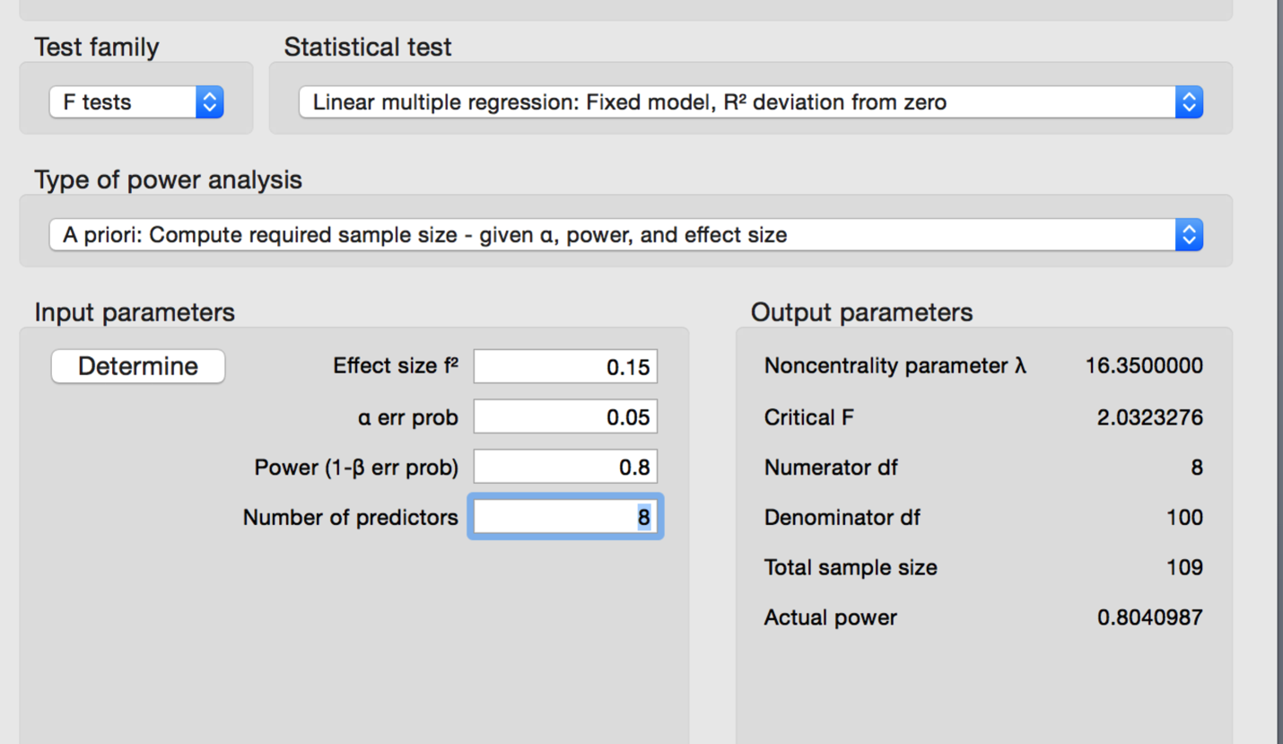

Assumptions:

* Multicollinearity – it’s ok.

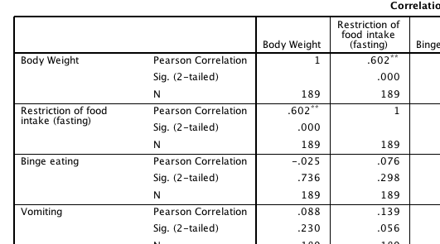

* Case Size – it’s ok.

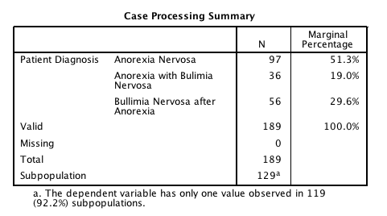

How to Run:

1. Analyze > Regression > Multinomial Logistic

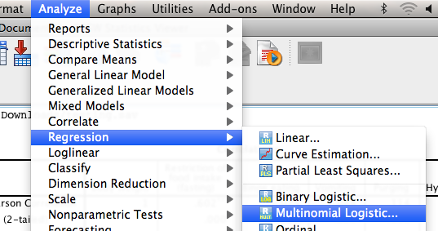

1. Put your DV/classification variable into the dependents box. Hit reference category. Pick first or last depending on who you want to compare to.

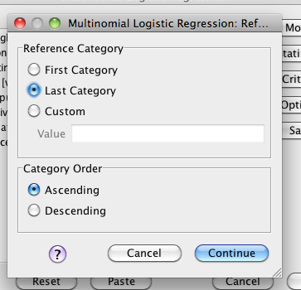

1. Put your categorical IVs into the factors box. Put your continuous IVs into the covariates box.

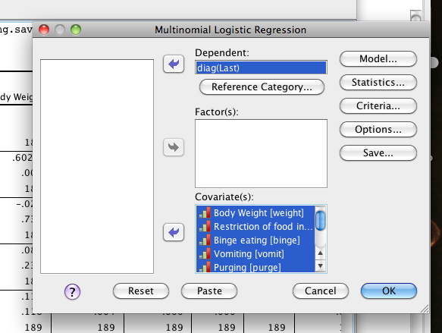

1. Hit statistics and ask for goodness of fit and classification table.

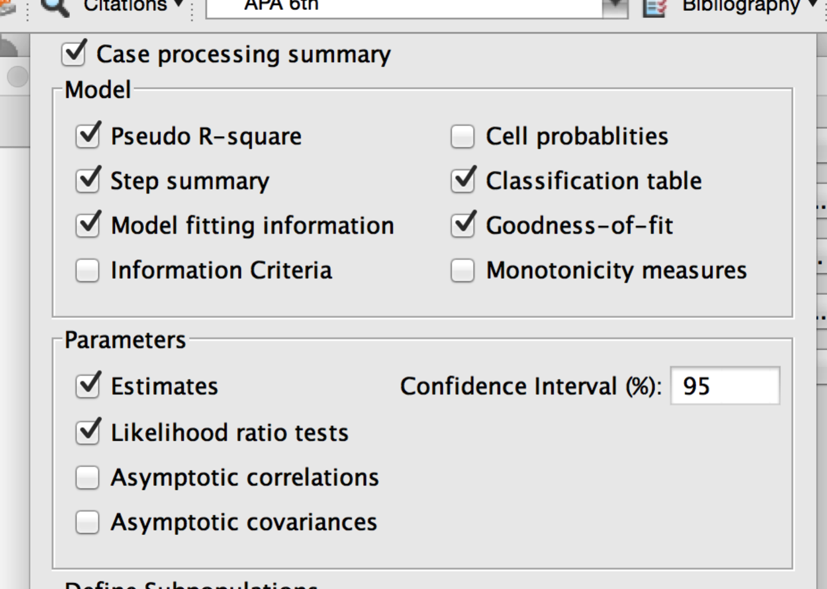

1. Hit ok to get the output.

Reading the Output – the output for this section is *easier* to read than the last section. It looks more like a set of regressions, and there isn’t a constant only model to compare to.

1. Model Fitting Information
   1. Here you can compare the constant to the final model (or steps if you run steps). We see that our model is a significant predictor of the classifications.

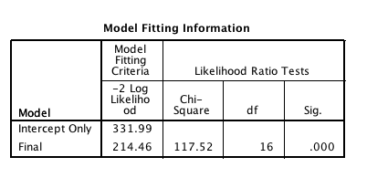

1. Goodness of Fit statistics – another way to say that your model predicts classifications well.

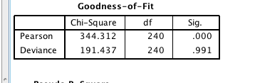

1. Pseudo R-Square – where you can find effect size for your final model.

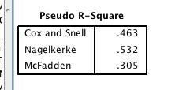

1. Likelihood ratio tests – this box tells you if overall (across both equations) your predictors were significant. Think about it like an ANOVA test – is the overall predictor significant? If so, which model was it a significant predictor for?

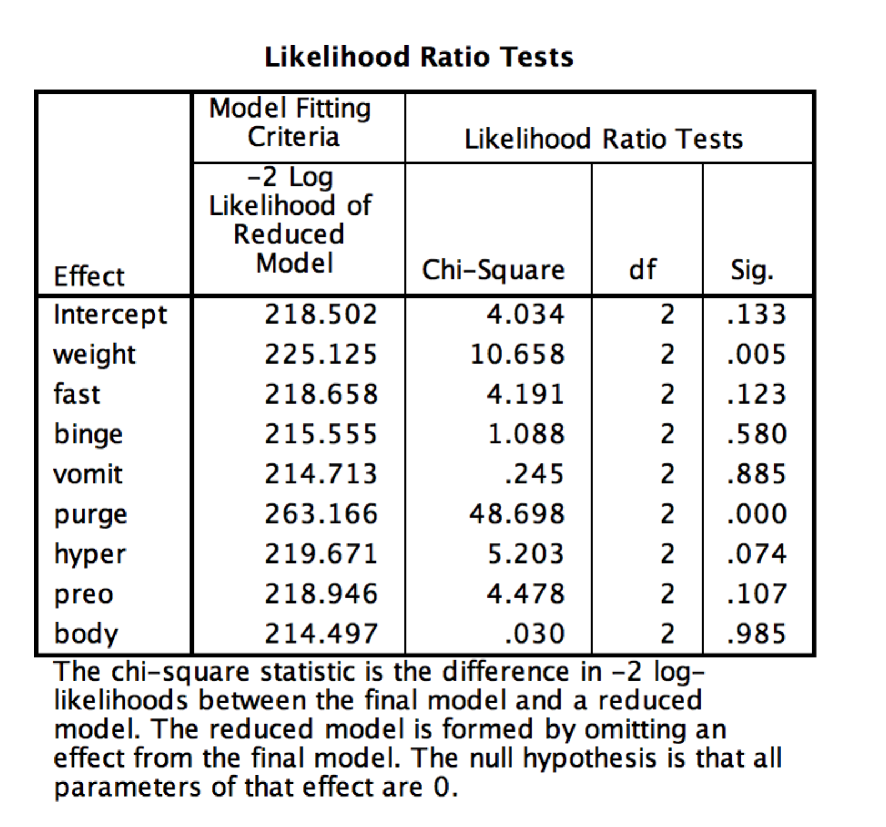

1. Parameter Estimates – this is where you’ll find both models (you get classifications – 1). You interpret this information in the same way as the last two analyses, but both equations compare against the reference group you set at the beginning (here bulimia after anorexia).

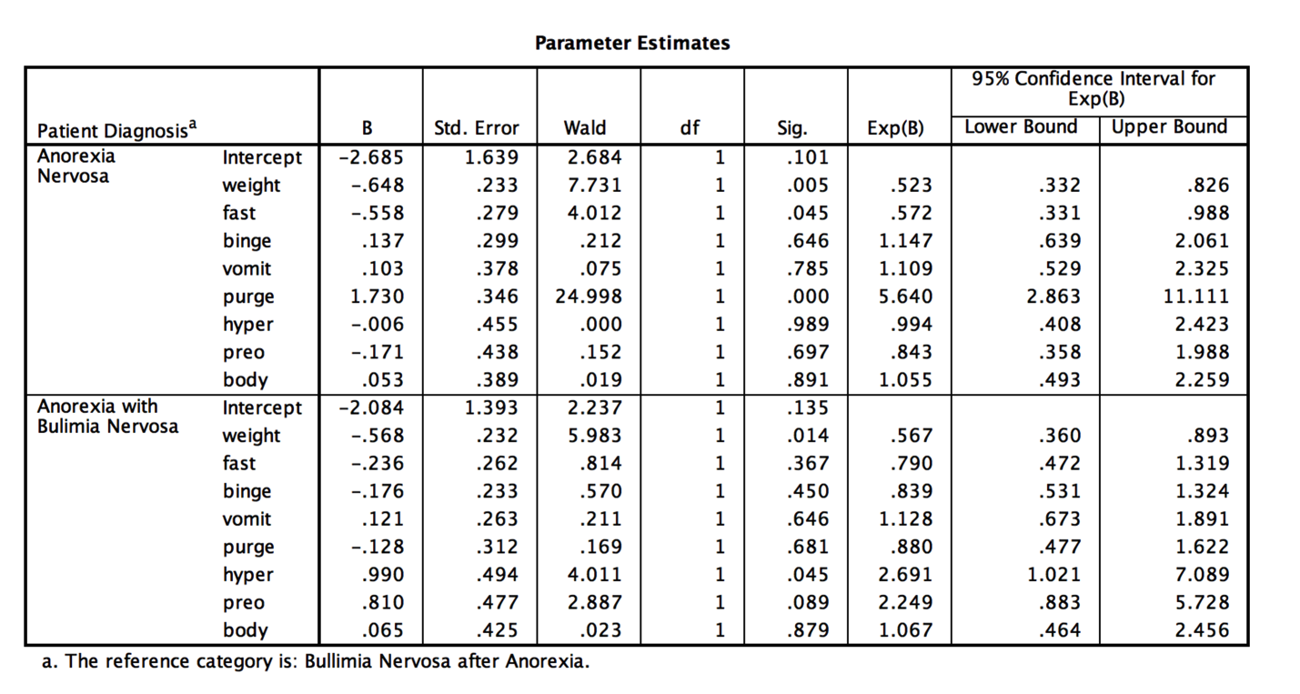

|  |  |  |
| --- | --- | --- |
|  | Bulimia after Anorexia | Anorexia |
| Weight | .523  As weight increases, more likely to be in the bulimia group |  |
| Fasting | .572  As fasting increases, more likely to be in the bulimia group |  |
| Purging |  | 5.640  As purging increases, more likely to be in the anorexia group |
|  | | |
|  | Bulimia after Anorexia | Both |
| Weight | .567  As weight increases, more likely to be in the bulimia group |  |
| Hyper |  | 2.69  As hyperactivity increases, more likely to be in the both group |

1. Classification Table – this table shows how well you did at classifying all three groups.

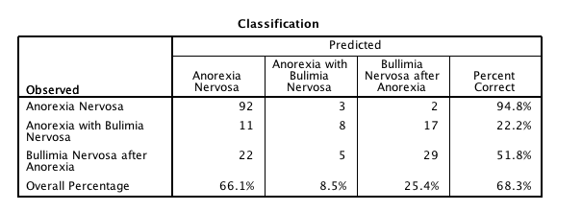

Results

A multinomial logistic regression was used to predict the differences between anorexia and bulimia and anorexia combined, as well as the difference between anorexia and anorexia that turns into bulimia. Scales were taken to determine a participants weight (low to normal), fasting, binging, vomiting, purging, hyperactivity, body view, and preoccupation with body weight (all none to obsessive). The data were screened and no problems (multicollinearity, missing data) appeared to be present.

Overall, both models were predictive of group classification, Likelihood X2(16) = 117.52, *p*<.001; Pearson X2(240) = 344.31, *p*<.001; Nagelkerke R2 = .53. The model correctly classified 68.3% of participants, with 94.8% of the Anorexic patients being classified correctly, 22.2% of the patients with both, and 51.8% of patients with Bulimia after Anorexia.

Table 1 contains the parameter estimates for both equations. When classifying the difference between bulimia after anorexia patients and patients with anorexia, only purging and weight preoccupation were significant. Anorexics were more likely to purge, while patients with bulimia were more likely to be obsessed with weight and fast. When predicting the bulimia after anorexia and patients with both diagnoses, bulimia only patients were again more likely to be weight obsessed, while patients with both were more likely to be hyperactive. See Table 1 for predictors.

Table 1. *Predictors for the Classification Difference Between Anorexia and Bulimia*

|  |  |  |  |  |  |  |
| --- | --- | --- | --- | --- | --- | --- |
| Patient Diagnosis |  | B | Std. Error | Wald | Sig. | Exp(B) |
| Anorexia Nervosa | Intercept | -2.685 | 1.639 | 2.684 | 0.101 |  |
|  | Weight | -0.648 | 0.233 | 7.731 | 0.005 | 0.523 |
|  | Fasting | -0.558 | 0.279 | 4.012 | 0.045 | 0.572 |
|  | Binging | 0.137 | 0.299 | 0.212 | 0.646 | 1.147 |
|  | Vomiting | 0.103 | 0.378 | 0.075 | 0.785 | 1.109 |
|  | Purging | 1.730 | 0.346 | 24.998 | 0.001 | 5.640 |
|  | Hyperactivity | -0.006 | 0.455 | 0.000 | 0.989 | 0.994 |
|  | Preoccupation with Weight | -0.171 | 0.438 | 0.152 | 0.697 | 0.843 |
|  | Body Views | 0.053 | 0.389 | 0.019 | 0.891 | 1.055 |
| Both | Intercept | -2.084 | 1.393 | 2.237 | 0.135 |  |
|  | Weight | -0.568 | 0.232 | 5.983 | 0.014 | 0.567 |
|  | Fasting | -0.236 | 0.262 | 0.814 | 0.367 | 0.790 |
|  | Binging | -0.176 | 0.233 | 0.570 | 0.450 | 0.839 |
|  | Vomiting | 0.121 | 0.263 | 0.211 | 0.646 | 1.128 |
|  | Purging | -0.128 | 0.312 | 0.169 | 0.681 | 0.880 |
|  | Hyperactivity | 0.990 | 0.494 | 4.011 | 0.045 | 2.691 |
|  | Preoccupation with Weight | 0.810 | 0.477 | 2.887 | 0.089 | 2.249 |
|  | Body Views | 0.065 | 0.425 | 0.023 | 0.879 | 1.067 |
| *Note.* Bulimia afterAnorexia Nervosa is the reference category, *df* = 1. | | | |  |  |  |